- On API label recovery call, we should add “Package dimension of 12x12x12 and weight of 2lb”. (Set as default on the body for the request? YES) by 12 which measure means? Inches I guess
- The Ship From information will be the customers logged in account shipping address. No input should be required at all from the customer. I guess in this case, we should not be using anymore the form Joseph did and all the data will be fetched from client? Where does the “Ship to” information comes from? I can get this data on runtime.user on model. Confirm with customer. Seems that the ship to is always “Turf Control”
See picture attached of what Form was before from Joseph: We are not going to use anymore a form.
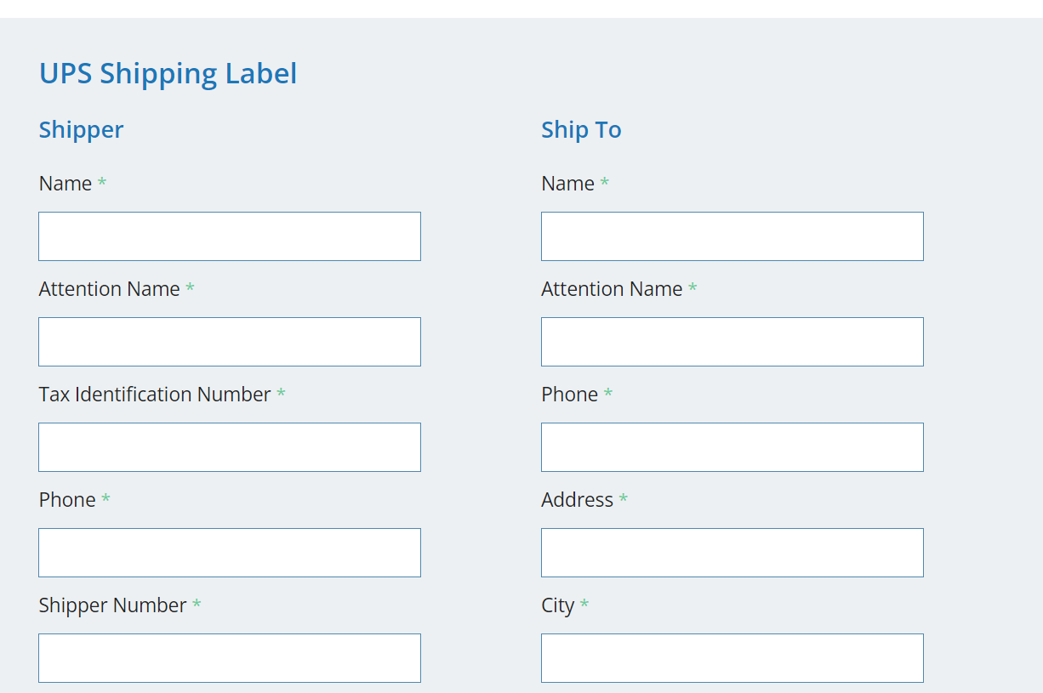
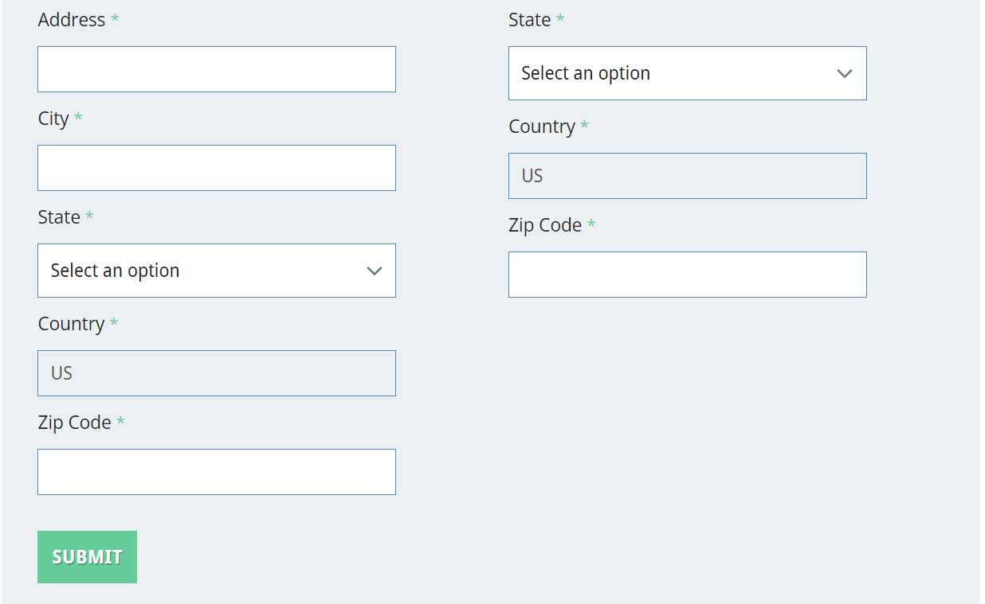
IN SOW: Include the logged in user ship from address and company information on the label.
- Just request a label takes to a landing page with the instructions of what to expect and a button that opens the label in a new tab to print out.” “Request a label takes to a landing page with the instructions of what to expect” This landing page mention seems out of scope, not in SOW. In SOW: ‘Allow the logged in user to download the label or print from new tab’. Currently what we are doing is giving back the URL which will lead to UPS site and will allow to print the label.
- Do not allow packages not in US states. Not in SOW.
- Allow the extension to be used from the home page, button should be in header with logged user always (we are using section on my account) Is this possible? Not recommendable? We can put a link that takes the user to the form. But we can not add a button in the header with a form inside, it would need to redirect to the site. Dijeron que no hacia falta.

Connection between packages, API.

To generate the UPS Shipping label, I need a response from shipment call. I created a service successfully to run UPS recovery label, however it does not have ship to and ship from attributes.
I found that UPS label recovery is used for the next:
For up to 90 days after when a customer schedules a forward or return the shipment, UPS maintains a copy of the shipping labels for 90 days. If a customer needs to print additional copies of a shipment label whether forward or return labels, the Label Recovery feature available within the Shipping API allows them to retrieve those labels.

My guess is that I should go ahead with shipment call.

Shipment call:
Seems that for this call, you need some kind of order data or something, like you need to provide a shipping option for it, how do I know that??
- Required parameters:
  - ShipmentRequest.Shipment.Shipper.ShipperNumber: You can find your account number (shipper number) on the top right corner of Page 1 of your bill.
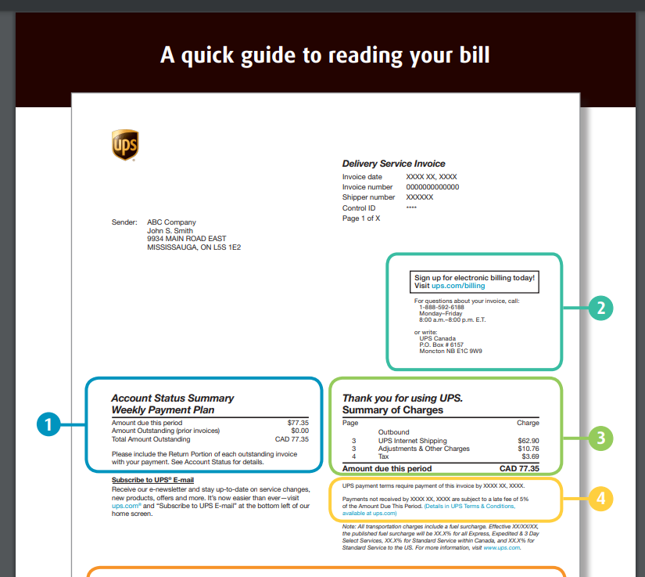
Regarding this, it’s on the bill, but for that I need the bill already created? So I need data of a sales order????
Shipper�s six digit alphanumeric account number.
Must be associated with the UserId specified in the AccessRequest XML.
The account must be a valid UPS account number that is active.
For US, PR and CA accounts, the account must be either a daily pickup account, an occasional account, or a customer B.I.N account.
Drop Shipper accounts are valid for return service shipments only if the account is Trade Direct (TD) enabled.
All other accounts must be either a daily pickup account or an occasional account.
This one, client attached txt with example. It’s always the same shipper number.

  - ShipmentRequest.Request.RequestOption: Valid values: nonvalidate = No street level address validation would be performed, but Postal Code/State combination validation would still be performed.��
  - validate = No street level address validation would be performed, but City/State/Postal Code/ combination validation would still be performed. Customer would need to tell which one they want)
  - ShipmentRequest.Shipment.Shipper.Name: Comes from customer name? (Do not know if it’s possible to do that on my account section since it’s asynchronous)
  - ShipmentRequest.Shipment.Shipper.Address.AddressLine / City / CountryCode: Same situation than previous
  - ShipmentRequest.Shipment.ShipTo.Name: From customers comment, they said that “no input should be required at all from customer”. How do we get this data?
  - ShipmentRequest.Shipment.ShipTo.Address.AddresLine / City / CountryCode: Same situation than previous
  - ShipmentRequest.Shipment.PaymentInformation.ShipmentCharge.Type: Valid values: 01 = Transportation 02 = Duties and Taxes 03 = Broker of Choice A shipment charge type of 01 = Transportation is required. (Customer would need to tell which one they want)
  - ShipmentRequest.Shipment.PaymentInformation.ShipmentCharge.BillShipper.AccountNumber: Same as ShipperNumber
  - ShipmentRequest.Shipment.Service.Code: Valid values: 01 = Next Day Air 02 = 2nd Day Air 03 = Ground 07 = Express 08 = Expedited 11 = UPS Standard 12 = 3 Day Select 13 = Next Day Air Saver 14 = UPS Next Day Air� Early 17 = UPS Worldwide Economy DDU 54 = Express Plus 59 = 2nd Day Air A.M. 65 = UPS Saver M2 = First Class Mail M3 = Priority Mail M4 = Expedited MaiI Innovations M5 = Priority Mail Innovations M6 = Economy Mail Innovations M7 = MaiI Innovations (MI) Returns 70 = UPS Access Point� Economy 71 = UPS Worldwide Express Freight Midday 72 = UPS Worldwide Economy DDP 74 = UPS Express�12:00 75 = UPS Heavy Goods 82 = UPS Today Standard 83 = UPS Today Dedicated Courier 84 = UPS Today Intercity 85 = UPS Today Express 86 = UPS Today Express Saver 96 = UPS Worldwide Express Freight. (Customer would need to tell which one they want or indicate us where to fetch it from because it seems to be a shipping method selected from the order) Different shipping methods, how do I know which one?? 01 = Next Day Air 02 = 2nd Day Air 03 = Ground etc
  - ShipmentRequest.Shipment.Package.Packaging.Code: Package types. Values are: 01 = UPS Letter 02 = Customer Supplied Package 03 = Tube 04 = PAK 21 = UPS Express Box 24 = UPS 25KG Box 25 = UPS 10KG Box 30 = Pallet 2a = Small Express Box 2b = Medium Express Box 2c = Large Express Box 56 = Flats 57 = Parcels 58 = BPM 59 = First Class 60 = Priority 61 = Machineables 62 = Irregulars 63 = Parcel Post 64 = BPM Parcel 65 = Media Mail 66 = BPM Flat 67 = Standard Flat. (Customer would need to tell which one they want)
  - ShipmentRequest.LabelSpecification.LabelImageFormat.Code: Label print method code determines the format in which Labels are to be generated. For EPL2 formatted Labels use EPL, for SPL formatted Labels use SPL, for ZPL formatted Labels use ZPL and for image formats use GIF. For shipments without return service the valid value is GIF, ZPL, EPL and SPL. For shipments with PRL return service, the valid values are EPL, ZPL, SPL and GIF. For UPS Premier Silver shipment only ZPL is supported. (Customer would need to tell which one they want, I assume GIF for Images)
  - ShipmentRequest.LabelSpecification.LabelStockSize.Height: Height of the label image
  - ShipmentRequest.LabelSpecification.LabelStockSize.Width: Width of the label image

  - Gives back the following data (which is in UPS recovery label):
    - LabelURL (I do not know if it’s the correct one)
    - Tracking Number
  - API example for the call is not working:
    - Account number is needed
    - ShipperNumber:
      - Six digit alphanumeric account number
      - Must be associated with the UserId specified in the AccessRequest XML.
      - The account must be a valid UPS account number that is active.

